**Title page**

***Title: The Picture of Dorian Gray***

***Author: Oscar Wilde***

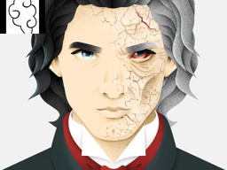

*Author of the report:Volodymyr Shepel #266617*

**Info page**

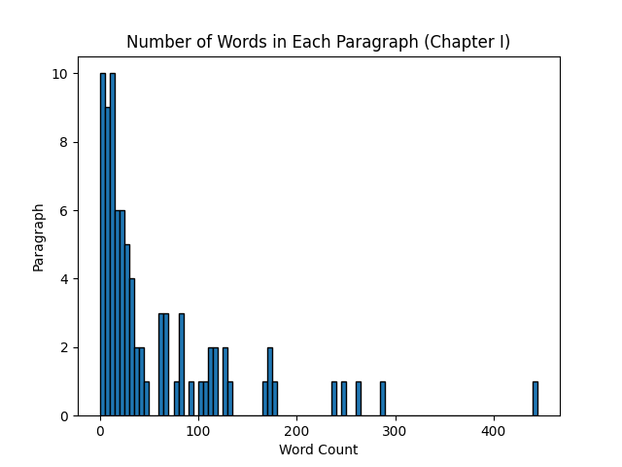

***minimal_number_of_words: 0***

***max_number_of_words: 441***

***mean_number_of_words: 58.583333333333336***

***number_of_paragraphs: 84***